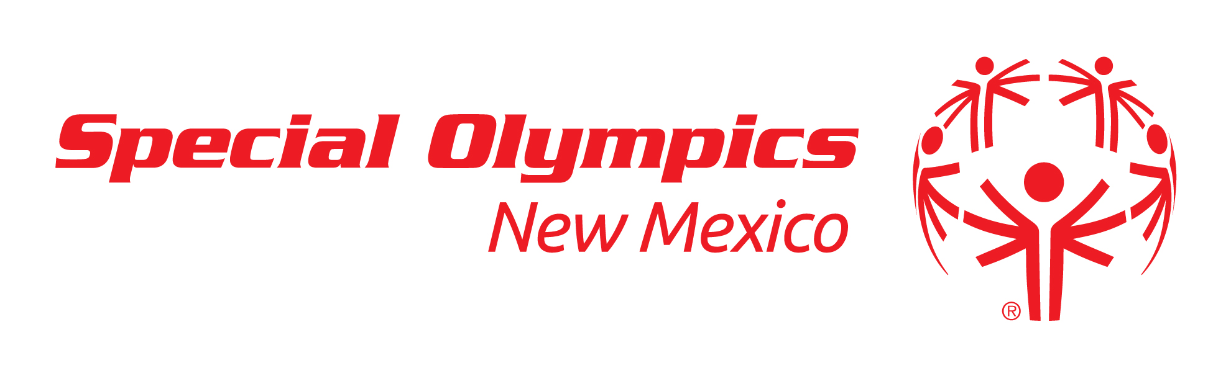
2017 Posole Ole
December 2, 2016
Anderson-Abruzzo International Balloon Musuem

Sponsor Benefits

Posole Ole Event Sponsor - $1,000

- Posole Ole Sponsor Designation
- Logo ID on Posole Ole apparel
- Company banner at competition venue
- Logo ID on select event promotional materials
- Name recognition during Awards Ceremony
- Name ID on all Posole Ole press releases
- Opportunity for volunteers
- Logo ID in Newsletter announcing Posole Ole (Biweekly)
- Company ID on all earned media coverage
- Logo and Name ID on all Posole Ole Social Media Communications
- Two (2) complimentary event t-shirts
- Thank you sponsor recognition award


